令和２年４月９日
保 護 者 様
大阪市教育委員会
大阪市こども青少年局
大阪市立丸山小学校
校長 松下 敦則

A state of emergency has been declared
School closure will continue

From the view point of infection prevention, school closures will continue until May ６（Sunday）. Children will spend time quietly at home, they cannot come to school.

１ The first day of school starts will be announced later.
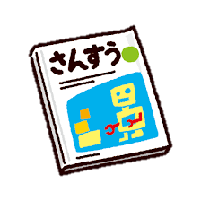
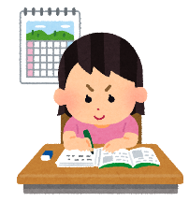
２ We will give you textbooks and homework
so that your child can study at home.
【The day to give textbooks and homework】
April 12(Sunday) ,13（Monday）,14(Tuesday)
１・６年生 ９：00 ～10：00
２・４年生 10：00 ～11：00
３・５年生 11：00 ～12：00

Please come to collect the materials at a fixed time.
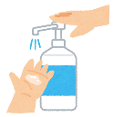
If you come, wear a mask, wash your
hands and disinfect your belongings.
Please bring a large bag for textbooks and homework.
３ If you have any trouble at home, such as being unable to spend time with family members, consult your school.
（丸山小学校 ０６－６６６１－６７３１ ）

４ Contact the school immediately if:
- A child has been infected with the new coronavirus.
- A child was known to be in with someone infected by hospitals and health centers.
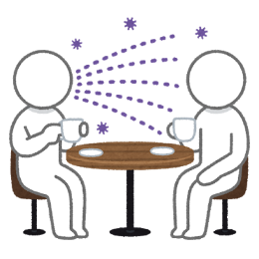
- Your family is known to have been in close contact by hospitals and health centers.
- A child has a fever of about 37.5 ° C.
- A strong (fatigue) and stifling (breathing difficulty)
Symptoms of cold and a fever of around 37.5 degrees
have continued for more than 4 days (including when
you have to continue to take fever reducing medicine).

Call "new coronavirus consultation health center".
０６ － ６６４７ － ０６４１

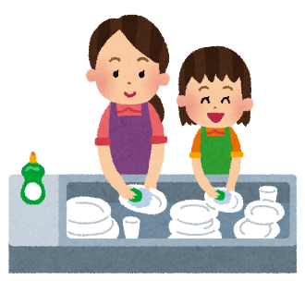
５ Have the child at home do the following:
- Help with housework。
- Do not go out as much as possible。
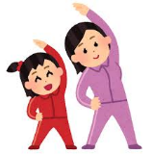
- Do exercise
- Take care of you and your family’s mental and physical health.
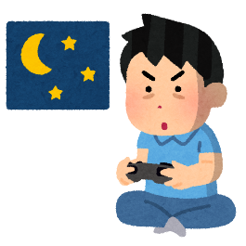
- Do not use your smartphone or play games for a long time.
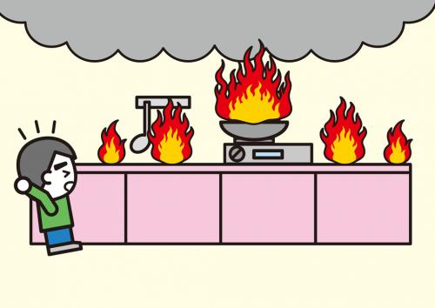
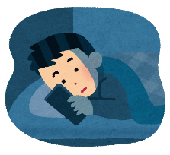
- Be careful not to cause a fire.

６ To stop the spread of the new coronavirus, keep the following in mind.
- Please make sure you get enough sleep and eat a balanced diet
- Hand washing is important. Please wash your hands frequently with soap or alcohol disinfectant when you go home, before and after cooking, or before meals.
- Refrain from going to places with large crowds and poor airflow
- Keep the air in the room moving.

